# Earthquake, Moon, Sun correlation project

This project is designed to analyze earthquake, solar and lunar gravitational data with the option of managing different graphs, histnorms, tables, trendlines for analysis. For this we consider in the earthquake data latitude and longitude, magnitude, depth, time, periods of the year, groupings by magnitude, groupings of earthquake clusters . On the side of the moon data we take into consideration the data coming from ... and we use the fraction of illumination, declination, and distance (r/km), tidal acceleration ???

Robert Bostrom in Tectonic Consequences of the Earth’s Rotation notes that; “ Von Helmholtz identified the species of motion (vortical) with respect to which there is no velocity potential in 1857. …, his insight has been disregarded by those of us struck by a tidal energy flux, astronomically well measured, that has seemed to “disappear” within the Earth. For scale, this is at least as great as that released in global seismicity. It may be desirable to examine the effects of actual external gravity, rather than those of a geocentric field that might well be attributed to Ptolemy. “

There is not a more perfect measurement of an “actual external gravity” than the phases of the moon. When the sun, the moon and the Earth are in syzygy , “actual external gravity” is at maximum and very well measured. It is unfortunate that 50 years of data amounts to less than 3 Earth/moon/sun perigean cycles each lasting 18.6 years. Contrast this to the well measured, almost 300 years of 25 solar cycles each lasting approximately 11 years.

Carlo Doglioni, notes in Polarized Plate tectonics, that it is an Earth’s scale phenomenology, and the energy necessary for its existence is not concentrated in limited zones (e.g., subduction zones), but it is contemporaneously distributed all over the whole Earth’s lithosphere, like the Earth’s rotation. Romashkova (2009) has recently shown how the planet seismicity indicates that the Earth’s lithosphere can be considered as a single whole. Only the global seismicity follows the Gutenberg-Richter law, while this simple relation does not hold when considering smaller portions of the Earth (Molchan, Kronrod, & Panza, 1997; Nekrasova & Kossobokov, 2006)….. The only mechanism that acts globally on the lithosphere and mantle is the Earth’s rotation. AND THE MOON AND SUN

Based on the previous discussions, the observed phenomenology of plate tectonics confirms mantle convection**, (there are waves on the ocean thus the ocean makes waves)** but it appears to be governed from the top, i.e., an astronomically sheared lithosphere travels westward along the TE, facilitated by the decoupling allowed by the presence, at the top of the asthenosphere, of a continuous global flow within the Earth low-viscosity LVZ that is in superadiabatic conditions (Figure 86).

Doglioni continues with, “The tidal forces are too small to generate earthquakes within continental areas, and for this reason they have been disregarded for long time.” Continental Clusters 58, 40, 18, 9, 16, 35, 22, 39,

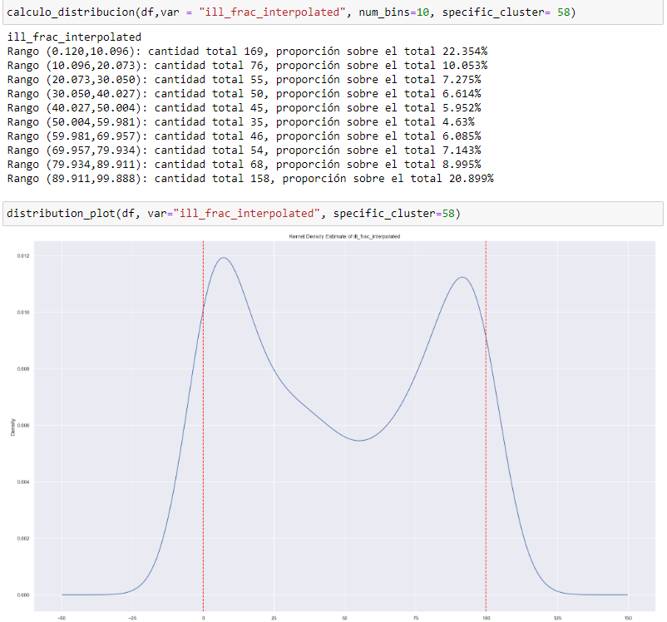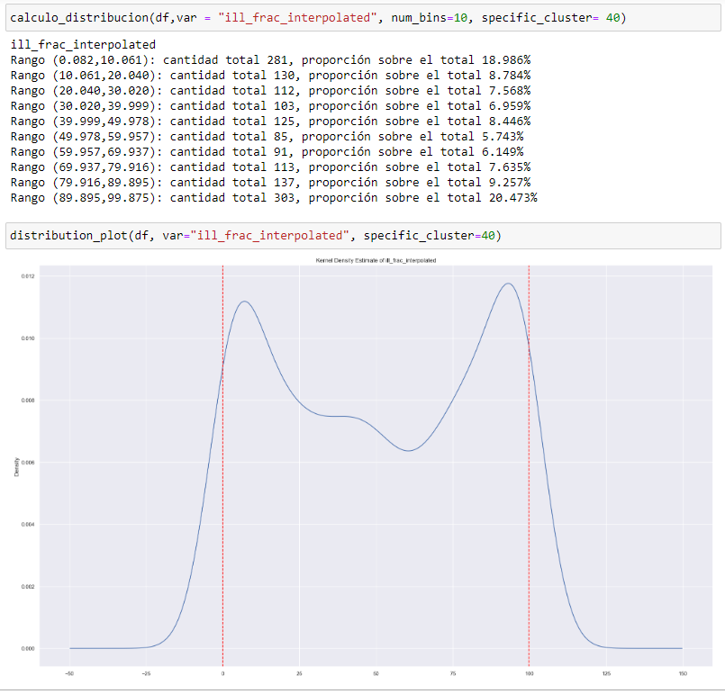

Some scientists have also suggested that plate tectonics may be triggered by the effect of tidal variations across many hundreds of millions of years (influence of the Moon and Sun’s gravity) (Riguzzi et al., 2010; Eppelbaum and Isakov, 2015). However, there is currently no theoretical or practical methodology for testing this hypothesis.

https://www.researchgate.net/publication/344075980_Plate_Tectonics_and_Earth_Evolution_A_Conceptual_Review 2020 november

What the graph allows us to do , besides "practical methodology for testing hypothesis" is very much like the "Bell curve",, it is a curve of probability and thus predictability . think of a name for this curve because it's going to be around for a long time

